**Overview**

The clients want a simple mobile app and website for Android, iOS and for windows phone to provide the social service to public. They want a user-friendly mobile app and website for people who want to donate food, clothes (with categories like, male, female, child, size, type of clothes, like t-shirts, pant, jeans or any other), toys, blood, blood platelets, medicines (excess after dose completion), time (can select date and time to share (might be for old age home, orphanage, hospitals, other social cause, writer for students, or any other activities) and various other items to kids at aanganwadi or slum areas or other needing person. They can also upload snaps of the same (toys, clothes or any items they are to donate). Needier can also create need. They also want to provide a service to health professionals and patients to maintain their medical records (Dr. Visit, prescription, pathology test visit, reports, hospital admission, discharge from hospital, bills, insurance copies, vitals (weight, height, waist, head circumference, pulse, body temperature, blood pressure, cholesterol, diabetes calories intake – by selecting portion of food and respected calories, calories burnt, with date, time and charts. Also able in mobile app and website so that they can easily access it anywhere and can keep records stored in cloud forever. Also can be shared with healthcare professional. They can also make to do list for appointment reminder with Dr., Pathology lab, blood bank, home health test. Anyone create camp event also (e.g., Blood camp, health camp…) and can share the same in social media. The same can be selected as event reminder by registrant to view in calendar and reminder too. Means, if I am a patient and I visit to Dr. - Dr. can see (one-time) my all health history with OTP (given by patient) from our app / website.

Admin can create “N” no.s sub-admin to create patients subscription via otp confirmation. Because it can be used by NGO, camp organizers for arranging data for camps.

Also we want “earn points” by donation and referral. And that points can be used against the goods (cart, e.g. head phone with “X” points, bluetooth with “y” amount, and so on.)

Also need some solution of confirmation of donation by needier and blood bank to confirm the donation.

**Solution**

We recommend development of a mobile app following current best practices in technology. This app will include forms, informational pages as well as a web based admin portal and content management system.

The app will include the following sections:

* App will have dashboard page where user can see and search the service without creating account and can take overview about the company & service offering.
* Donating anything and using any service the user will have to login or register their self in app.
* App will have registration facility to register new users as per their profession.
* The health professionals and patient will have facility to add their medical records in multiple sections.
* The user will have a facility to search the arears where they donate the blood, food donner or anything else they want to donate.
* The user will have a facility to create records for any person.
* The user will have GPS search facility to search the nearest location to donate the items.
* The user will have a section like allergies, Blood test and urine other test, Consultation notes, contacts, documents (bills, reports etc.), drugs and personal data. All these section will have many subcategories to managing and maintaining their records.
* The user will have a search facility to search the donner or place the requirement for the blood, food, and clothes to anything they are having the requirement for any areas.
* The user will have notification sections to get the notified by admin or company.
* The user can create the group or circle in the app through their contacts.
* User will have a facility to update their personal information like:- Photo, emails, address, mobile number, profession etc.
* User will have the setting sections where they can set the permissions, languages etc.
* User will have help section to get connected with support team for any queries.
* The user will have a facility to change their password or then can resent it by email verification if they forgot the password.

**The App Admin panel will have following features:**

* Admin will have an authority to delete or add any user profile in app.
* Admin can send notification to any specific user or multiple users for providing them any update.
* Admin will have a dashboard to see the analytics for the current status.
* Admin will have facility to generate reports for monthly, weekly & daily bases for user registration, billing, donation etc.
* Admin can monitor to their entire request for donation by the donner or requisition.
* Admin will have facility to search any donner by the location.
* Admin will have section to keep mention records for donner for the future requirements.
* Admin will have follow up reminder facility to save the date and time to follow up to any donner for the donation.
* Admin will be able to add location in app by the GPS tracking for any new locations.
* The entire system will be built on automation for sending a quick emails & SMS on any requisition to donners.
* The entire architecture of admin panel will be fully automated with the system like report management system, user management system, help desk etc.
* Admin can change their user ID password.

**Solution Architecture**

Entire solutions will be built on a multi-tier architecture using RESTful Web services. The back-end will be deployed on Amazon AWS Cloud which will ensure that the entire platform comprising of Website, Mobile Apps and CRM works reliably and is capable of supporting a high volume of traffic while remaining protected from malicious entities.

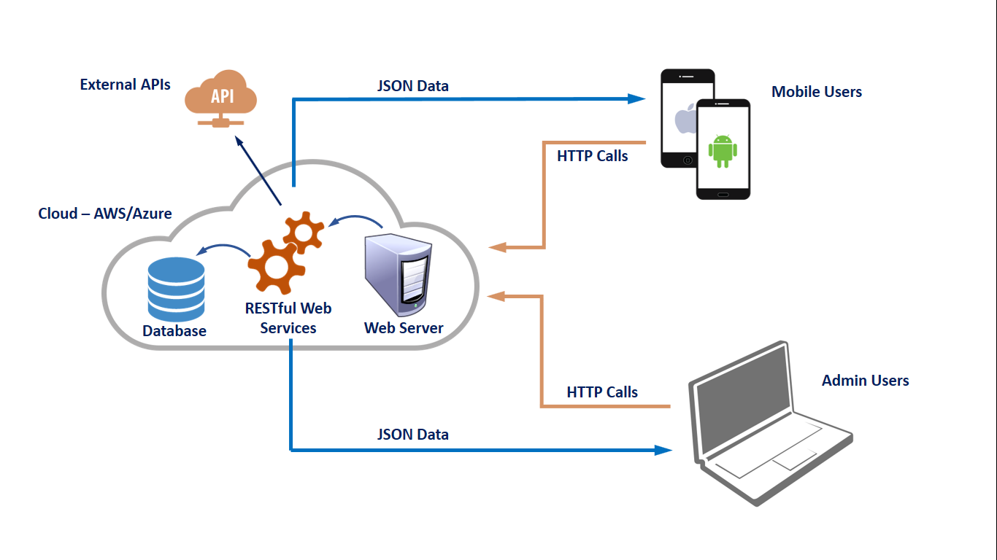

**Technology Stack**

* Mobile App - Hybrid Apps using Ionic/Cordova
* RESTful API – Node.JS / JSON / C#
* Storage – PostgreSQL / SQL Servder
* Admin Web Portal – Angular / HTML5 / JavaScript
* Website – HTML5 / CSS3 / JavaScript
* Web Server – Nginx / IIS

**Execution Strategy**

Our execution strategy incorporates proven methodologies, qualified personnel, and highly responsive approach to managing deliverables. Once your project kicks off, here's what to expect:

1. Requirement Study & Documentation

Based on the discussions and review of existing work process a detailed Software Requirement Specification (SRS) document is prepared which contains proposed functional and technical specifications. These specifications serve as a roadmap for further step.

1. System Design

Taking SRS as input and evaluating various technology options and best practices, an Application Architecture for the software is planned out. System Design also involves preparation of various diagrammatic representations of the logical and physical artefacts to be developed during the development stages to follow.

1. Coding

On receiving system design documents, the work is divided in modules/units and actual development starts and the product is built. If the design is performed in a detailed and organized manner, code generation can be accomplished without much hassle.

1. Testing

The testing phase commences after a development release has been completed. Our Quality Control (QC) group, tests all the functionality in the application. The development and testing phases are performed iteratively as issues are found, corrected, and retested. After completion of QC, the next critical testing activity is User Acceptance Testing (UAT)

1. Deployment

After successful testing the product is delivered / deployed to the customer for their use. If any changes are required or if any bugs are caught, then they will report it to the engineering team. Once those changes are made or the bugs are fixed then the final deployment will happen.

1. Maintenance

Post deployment the application enters maintenance mode and is supported under an Annual Maintenance Contract (AMC). This ensures that the application continues to perform at optimum level and any operation issues, technical glitches are resolved quickly.